**Multiscale Modeling of Dynamin Oligomers**

**Patsy J. Griffin**

At the cellular level many important processes require the collection of large-scale protein oligomers, including membrane fusion and endocytosis. A GTPase protein known as dynamin is specifically responsible for endocytosis in the eukaryotic cell. During clathrin-mediated endocytosis, the cell membrane invaginates to form a budding vesicle [1]. Dynamin binds to and assembles around the neck of the endocytic vesicle, forming a helical polymer arranged such that the GTPase domains dimerize in an asymmetric manner across helical rungs [2]. Gaining understanding of how large-scale oligomerization causes changes within the cell can be difficult due to the various lengths and time scales which are involved in these processes. Both experimental and computational approaches to studying these problems can bring important insights to these processes, although it can be difficult to fully capture the multiscale nature of the system. As a way of combatting these difficulties, multiscale molecular dynamics will be used as an approach to study complicated cellular systems because it is able to take into account the multiple length and time scales involved, and can show how their cooperation leads to major changes in the cell.

Figure 1: During endocytosis, dynamin forms a helical coat that allows it to catalyze GTP hydrolysis and leads to scission of the lipid vesicle. Image from Harvey McMahon’s endocytosis.org website.

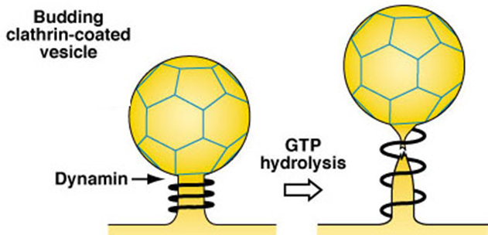

**Multiscale Computer Simulation as a tool for Studying Biological Systems**

Multiscale modeling methods connect coarse-grained simulations of large biological systems with the molecular-level resolution of all atom molecular dynamic simulations. As one of the major difficulties being that previous methods were unable to take into account various lengths and time scales, these simulations can handle the different scales which are associated with cellular systems [3]. Experimental results and existing simulations are combined to create coarse grained models which are used to provide new insights and be tuned to explore competing explanations of experimental results. These low-resolution simulations can then be used to restrain and guide all atom simulations, which help to suggest new experiments, provide new molecular-level explanations of existing experiments, and help improve the original model overall. In terms of sources of funding for this project, as a graduate assistant I would work under an experienced mentor who would secure grants and provide support to myself and the rest of the research group. Being on the university campus, a fully equipped computer lab would be at my service with all the necessary protein modelling software.

**Innovative Multiscale Models of Dynamin**

The plan is to develop innovative multiscale models of dynamin that combine simulations of the enzymatic hydrolysis of GTP, the interaction of the PH domain with the membrane, and the motions of the protein in solution to develop a CG model that reproduces the underlying physics and biology seen at the molecular scale. Additionally, enhanced sampling methods will be used to accurately determine the free energy landscape of the allosteric change that occurs during hydrolysis and the interactions of the PH domain with the membrane. The CG model will be used to simulate large scale oligomeric dynamin helices on the membrane and as a result determine the energetic driving forces of dynamin induced membrane fission. Forces from the previous simulations will then be used to guide the AA simulations into configurations that would normally not be sampled. This will allow for the understanding of how large-scale interactions affect molecular level processes.

**Intellectual Merit**

By using multiscale MD to study large-scale protein oligomerization there is an opportunity to bring important new insights into how small-scale molecular interactions lead to large changes in the cell. The models to be developed will bring together many different experimental and computational studies to elucidate the underlying mechanisms at work in cellular processes. These constructed models can also be used to test current competing explanations for biological and disease mechanisms. By constantly feeding the information back and forth between the atomic and CG levels of resolution, a full picture of how biology couples the very big and very small changes in the cell can be created. While much experimental work has been done to understand the process detailed above of how dynamin functions, there has been no clear consensus made on what the ultimate mechanism is. Of the many proposed, there are two main mechanisms for dynamin induced membrane fission that are at the forefront. Distinguishing between these two models, requires two key major points to be understood: 1) how is the energy released from GTP hydrolysis used by dynamin and 2) how is the super-constricted membrane state reached? The overall goal of this work is to develop a multiscale model of dynamin that can be used to determine whether dynamin induced membrane scission occurs via a constriction or protein coat disassembly mechanism. Results of this project can be helpful to alleviating dynamin dysfunction within the cell, which knowingly leads to several different health difficulties including Charcot-Marie-Tooth disease and epileptic encephalopathy.

**Broader Impacts**

The work proposed here will help to determine how different levels of scale all work together to cause the fission of lipid vesicles by dynamin. The results will bring new understanding to existing experimental work by connecting them together and showing how the experiments illuminate different aspects of the overall fission mechanism. By identifying important protein-protein interactions, new mutation studies can be suggested to test how these proteins interact with each other. Through working with collaborators, we can model the effect of these changes to the protein to determine how it affects in vitro tube fission. Using a multiscale modelling approach will allow us to understand how cooperative activity between dynamin and endophilin lead to membrane fission. The multiscale modelling showcased in this work would help lead to an overall understanding of the mechanism of dynamin and highlight large scale interactions within the cell, both of which is a remarkable feat in both the computational and health fields.

**References**

[1] Le Roy C, Wrana JL. Clathrin- and non-clathrin-mediated endocytic regulation of cell signaling. Nature reviews Molecular Cell biology. 2005;6:112-26.

[2] Doherty GJ, McMahon HT. Mechanisms of endocytosis. Annual review of biochemistry. 2009;78:857-902.

[3] Ayton, G.S., E. Lyman, and G.A. Voth, Hierarchical coarse-graining strategy for protein-membrane systems to access mesoscopic scales. Faraday Discussions, 2009. 144: p. 347-257.